**Lab 1**  
  
**Datasets used:**

* Chronic Disease Indicator(Source : Data.gov)

<https://catalog.data.gov/dataset/u-s-chronic-disease-indicators-cdi>

* A statistical research on the effects of mental health on Student’s CGPA (Source: Kaggle)

<https://www.kaggle.com/datasets/shariful07/student-mental-health>

* World University Ranking (Source: Kaggle)

<https://www.kaggle.com/datasets/samiatisha/world-university-rankings-2023-clean-dataset>

Dataset 1:

dn.info() : It prints the information of the dataset such as number of columns,   
 column name and the data type.  
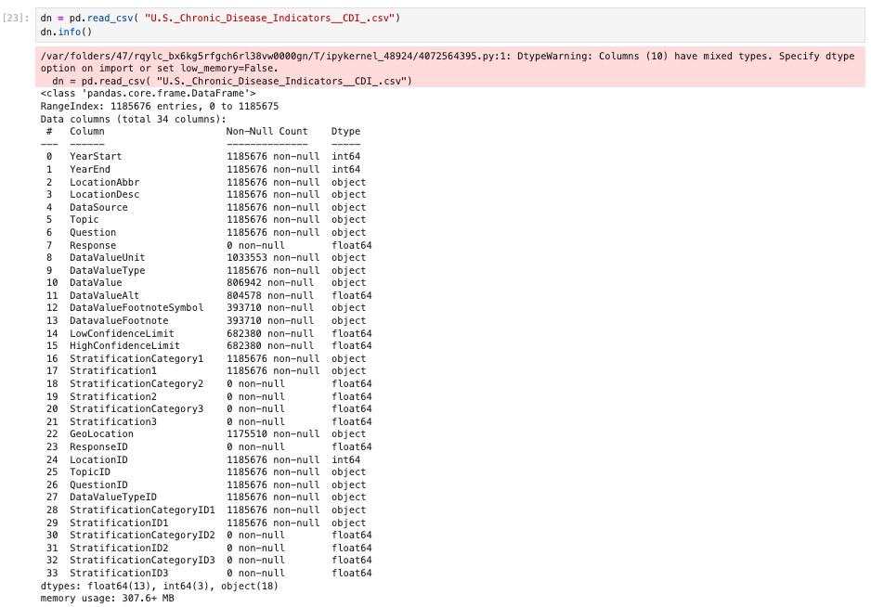  
  
 dn.head() : It gives the content of the dataset.  
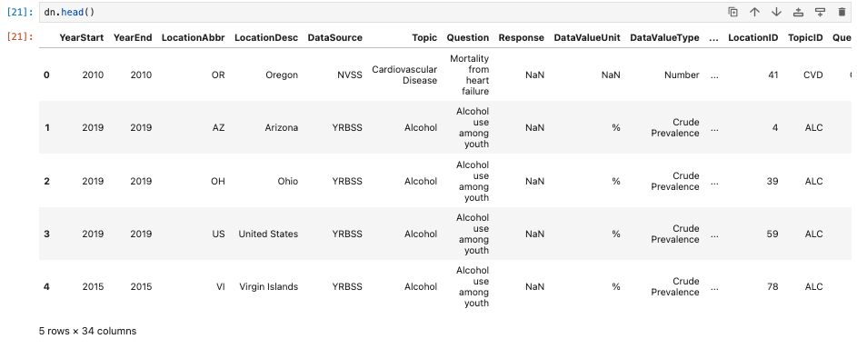

dn.shape() : It gives the number of rows and columns of the dataset.  


Dataset 2 :

ds.info() : It prints the information of the dataset such as number of columns, column name and the data type.

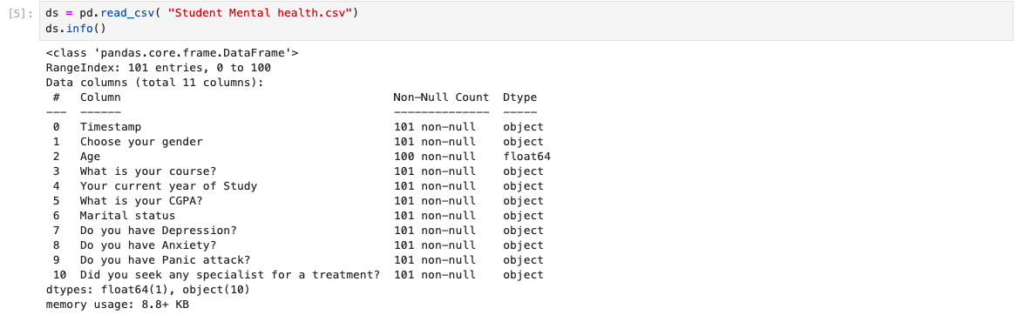

ds.head() : It gives gets the content of the dataset.

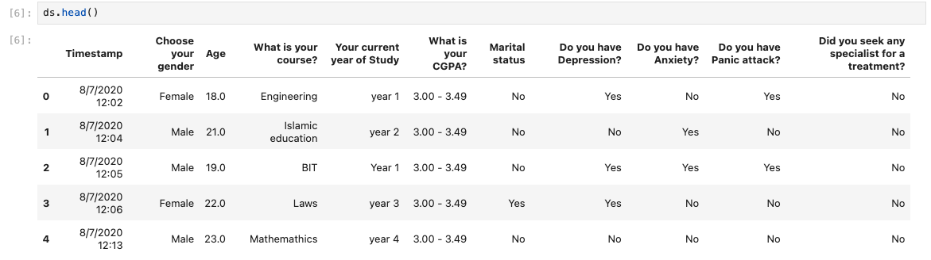

ds.shape() : It gives the number of rows and columns of the dataset.  


Dataset 3:

ds.info() : It prints the information of the dataset such as number of columns, column name and the data type.  
  
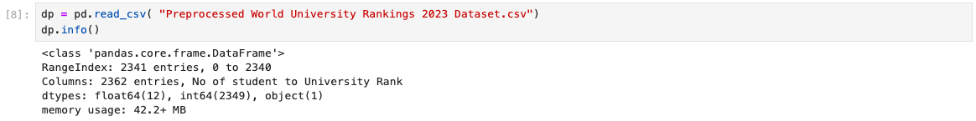

ds.head() : It gives the content of the dataset.  
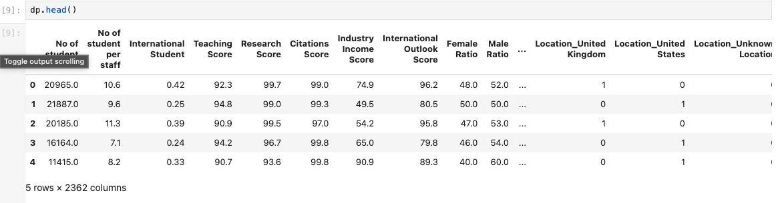

ds.shape() : It gives the number of rows and columns of the dataset.  


**Difference and Similarity of the dataset**

Dataset 1 is a public health dataset that talks about 124 indicators designed through consensus, enabling consistent definition, collection, and reporting of chronic disease data across states, territories, and major metropolitan areas.Dataset 2 talks about a statistical research on the effects of mental health on students CGPA dataset and Dataset 3 talks about the World University Ranking 2023.The three dataset consist of mixed information as the dataset deals with different topics. The dataset 2 contains Timestamp, Choose your gender, Age etc whereas dataset 3 No of students, No of students per staff, International Student etc.

**Summary**

We have analyzed the three different dataset we found from kaggle and data.gov. We ran a few panda functions such as .info(), .head(), .shape(). We found the following difference and similarities mentioned between the datasets above.